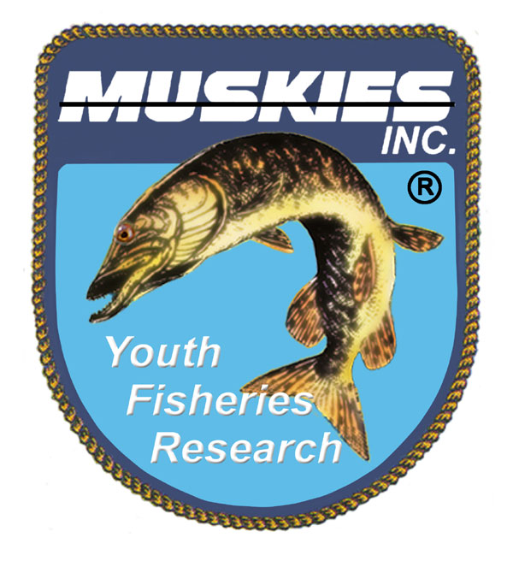
HALF A MILLION DOLLARS DONATED BACK TO MUSKIES AND FISHERIES
Well almost half a million, $498,135 to be exact. So, the Hayward Lakes Chapter of Muskies Inc. has fundraised almost half a million dollars over the past forty-three years and donated to, and funded 339 projects starting in 1979.
The largest source of income has been our Annual Fall Tournament which has been held forty-three times, drawing almost 500 participants in 2019. Other income has come from sources like raffle ticket sales, partnering with the Wisconsin Muskie Alliance and their Ranger boat. We have received donations from the Hugh Becker Fund and some private individuals, organizations and companies.
All of the donations were recorded and kept track of, starting with a paper chart and moving to electronic records in recent years. The complete chart can be seen on our website or Facebook. We also have the chart mounted on, four large poster boards which we bring to our events for face-to-face viewing. This lets large numbers of people, like the five hundred people at our tournament, see where their money goes.
One of the chapter’s primary goals in past years was stocking. From 1983 to 2006, the chapter stocked 26,795 fish, with a value of $200,053. In recent years, we have not been able to continue to stock because the DNR wants any fish going into a lake to be the same fish, genetically. So, if the DNR says we can stock Round Lake, they must be Round Lake fish. All the lakes in Sawyer County are natural Muskie waters so this will keep the lakes strain pure. In recent years we have not been able to find a hatchery that will raise a particular strain of fish for us.
Luckily our chapter has found another way to help with stocking. We buy additional minnows for feed, for the fish being raised in the hatchery. This makes the fish grow larger by several inches and thus increases their ability to survive. The DNR has proven this when they go back and do surveys, they find an increased number of stocked fish.
When the fish are stocked, we have provided funds to purchase “pit tags”, along with the DNR, that are inserted into the fish prior to stocking. These tags are half an inch long, about the size of a pencil lead. They each carry a number that can be read by passing a scanner over the fish. These do not require charging and last the life of the fish. When these are put in stocked fish each fish is measured to the eighth of an inch and the number recorded. When the DNR nets fish in the spring these fish also get tagged. The scanners have also been purchased by our chapter. They have gone to DNR staff, local guides and chapter members. The end result is that state biologists now can better estimate population numbers, growth rates and fish movements. This tagging proved the importance of providing the additional feed prior to stocking. There are over 20,000 tagged fish on Sawyer County. We want to thank our local DNR biologist, Max Wolter and his crew for their efforts here.
Scholarships are another area that the Hayward Chapter has invested money in. Starting in 2007 through the present we have awarded forty-one scholarships, totaling $39,250. Some of the scholarships have gone to local students, most go to students at UW Stevens Point who are studying to be fish biologists. Currently we award two $1,500 scholarships each year.
Our chapter has held 20 “Kids Fishing Days” starting in 2000. We have invested $26,421 in these events. Each youngster fishes with a guide and then after a picnic lunch they get a bag of fishing goodies worth $40. We also donate to other events for kids hosted by The Hayward Bass Chapter, Walleyes for Northwest Wisconsin and The Hayward Lions Chapter.
Most of the projects and events we have funded have been local, in the Hayward – Sawyer County area. We have, however, been donating to The Gil Hamm Fund in remembrance of our founder. The fund has received $16,058 from our chapter.
We have provided the Spooner Hatchery with assistance for a variety of needs including nets, a transportation tank and fencing to keep out otters. For their work boats, we paid for repairs and improvements, we bought a new and more powerful outboard for one and locators with GPS. The current total here is $22,017. Hundreds of gallons of minnows have been purchased at a cost of $28,894 so the Muskie fingerlings can grow as large as possible.
A variety of fish related projects have been invested in over the years. These include piers, launch ramps, pike removal, telemetry studies, land purchases, weed eradication, investing $20,871. We have provided pit tags and readers costing $12,916.
Going into the future we expect to be able to continue assisting and improving the Muskie habitat, helping with other fisheries needs and conservation efforts in the Sawyer County area, and striving to educate and inspire the next generation (our youth) to foster a love of fishing and care for the environment. Our primary fund raiser, our Fall Tournament this year is October 1st, 2nd and 3rd of 2021. Join us for some challenging fun!
Mike Persson, President
Hayward Lakes Chapter of Muskies

